Youth Summer Camp 2015
Application Form
Quotes from campers:

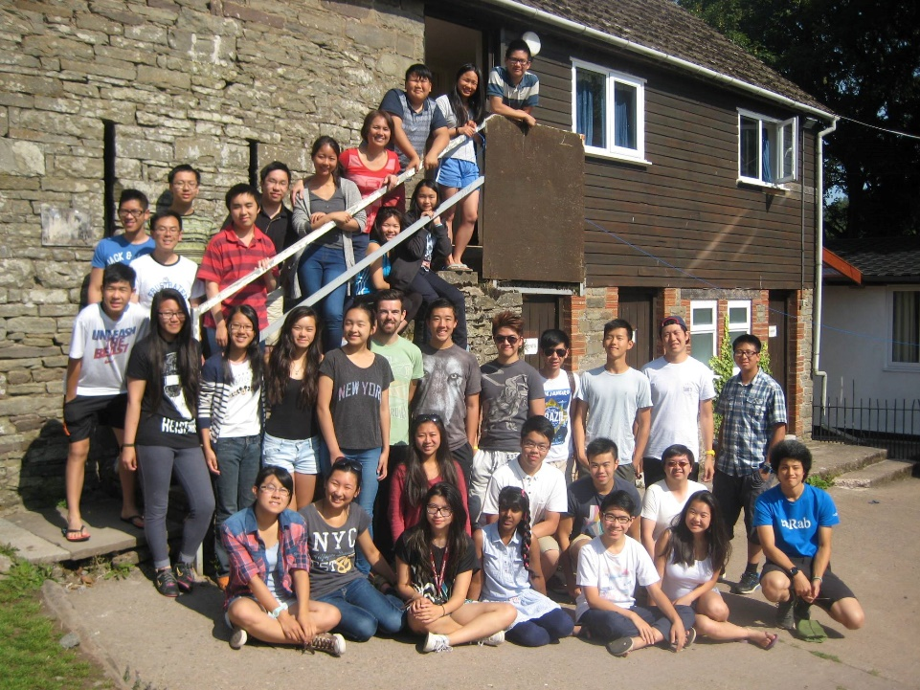
‘The talks were good’
‘I loved the campfire’
‘A great experience’
‘The food was great’
‘I couldn’t stop laughing’

‘I loved canoeing’
‘The best week of my year’
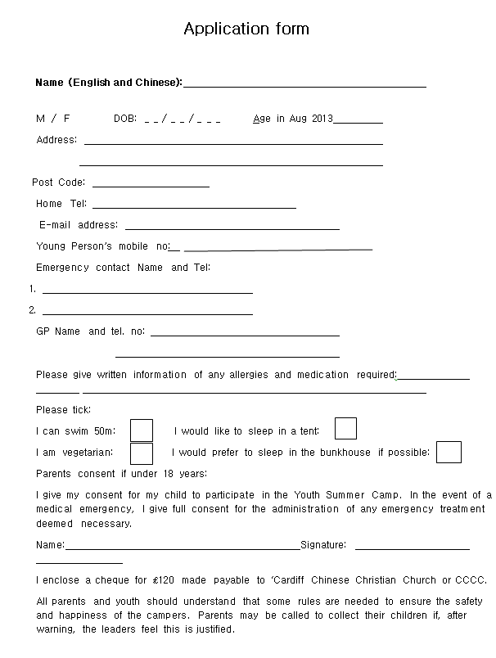
2015
55
Cardiff Chinese Christian Church - Youth Summer Camp
Sunday 2nd – Fri 7th Aug 2015
Clyngwyn Bunkhouse
Ystradfellte Rd Pont Nedd Fechan, Pontneddfechan, West Glamorgan SA11 5US 01639 722 930 www.bunkhouse-south-wales.co.uk
We have planned a wonderful five days of fun for youth aged 13+. We will have a bunkhouse to sleep 19, field and indoor games area.
Each day will start with a time of Worship and Bible Study.
Other activities will include: Campfire, Bible Study, Walk to the Waterfalls, Langorse Lake Boating and Fishing, and lots of Games.
Please look at the kit list. We will leave on Sunday 2nd August at 2.30pm from the church and return Friday 7th in the afternoon.
Please return application form with full fee of £120
(Cheques made payable to ‘Cardiff Chinese Christian Church or CCCC) to:
Shau-Wai Sim, 2 Triscombe Drive, Cardiff, CF5 2PN
Tel: 029 20 566 908 Closing date 05.07.15
There will be a meeting for campers and parents on Sunday 26th July 1pm in the main church.

